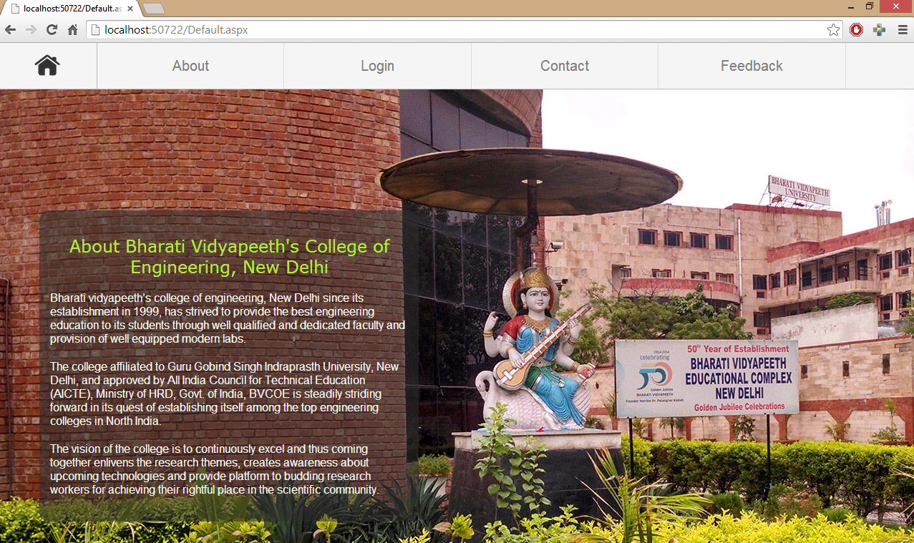

Aditya Dev Sharma Divyanshu Sharma

D

Online Attendance portal

Online attendance portal framework customized for Bharati Vidyapeeth’s College of Engineering.

Attendance portal

Aditya Dev Sharma Divyanshu Sharma

ASP.NET Project

## Software Used:

Visual Studio 2013

## Objective

To create an online attendance database system.

## Synopsis

The website has been created with the purpose of providing an attendance management system for an institution.

Teachers can upload students’ attendance records on a daily basis. These records can then be checked by the students or their parents by using a unique login ID.

This system can be used for easier management and manipulation of attendance data and to prevent ambiguity.

## Working

The system consists of two components:

* Administrator/Teacher access
* User/Student access

### Administrator

* An administrator is required to input the class data for various streams and batches in the institution.
* Database tables are respectively created for each stream, consisting of the names, enrollment numbers, etc. and the subjects of the classes.
* The administrator further has the privileges of accessing the class data, modifying and deleting the records.

### Teacher

* Teachers are provided with the access to the class records, which they can use to mark the attendance of the students.
* Checkboxes are provided to increase ease of access.
* The marked attendance is entered into the class database and the percentage attendance is calculated for the student view.
* Teachers also have the permission to view and modify the class records.

### user/student

* The website is used to provide a login platform that students can use to check and verify their attendance, using their unique ID, which is used to fetch their respective attendance in each of their subjects.
* Individual and cumulative percentages are calculated and displayed for each student based on the attendance record uploaded by the teachers.
* Students only possess the access to their own attendance records.

## Future Scope

This website has been developed based on an online attendance portal framework that can be customized based on the requirements of an institution.

It can be used for easy management of attendance records, as well as to increase the transparency of the process, as the system has the capability of being updated on a daily basis.

Implementation of this system can make the process of keeping attendance records more convenient.

### BIBLIOGRAPHY

Online Resources

<http://www.stackoverflow.com>

<http://www.csharp-station.com>

<http://www.w3schools.com>

<http://msdn.microsoft.com>